Pokhara University

Level: Bachelor | Semester – Spring | Year : 2008
Programme: BE |  | Full Marks: 100
Course: Control System |  | Time : 3hrs.

Candidates are required to give their answers in their own words as far as practicable.
The figures in the margin indicate full marks.

Attempt all the questions.

R | - Differentiate between open loop and closed loop systems. Explain an example of closed loop system.  - Obtain the overall transfer function of the system shown in the figure below using signal flow graph technique.  1  G₁  G₂  -G₄  G3  C  -H₂  -H₁  -1 | 8  7
 | - Obtain the transfer function of the system using block diagram reduction technique.  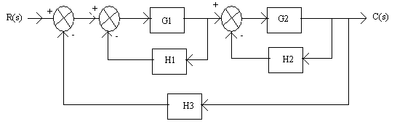  - A unity feedback servo-driven instrument has an open loop transfer function.  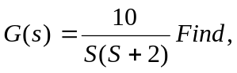  - the time domain response for a unit step input.  - the maximum overshoot and the peak time.  - steady stale error to an input 1 + 4t | 8  7
 | - What is relative stability? How it is affected by the location of the closed loop poles?  - Write down the differential equations governing the armature controlled DC servomotor.  - Write the state equation for the circuit shown below. | 3  6  6
 | - The characteristic equation of a feedback control system  s⁴ + 20ks³ + 5s² + 10s + 15 = 0  Find the range of k for which system is stable.  - Draw the root locus diagram for the following open loop transfer function GH(S) = K/s(s + 4) (s² + 4s + 20). | 7  8
 | - Sketch the Bode plot for the transfer function G(s) = 50 / {s(1 + 0.25S)(1 + 0.1s)}. Determine the gain margin, phase margin and the system stability.  - Sketch the polar plot of the system G(s) = 10 (s + 1) / (s + 10). | 9  6
 | Design a lag compensator for a system whose open loop transfer function is G(s) = K / {s(s+1)(s+4) to meet the following specification. Damping ratio = 0.5, Settling Time = 10 seconds and velocity error constant = 5. | 15
 | Write short notes on (Any Two)  - Eigen values and eigen vector.  - Frequency domain specifications.  - Analogous system (force-current and voltage analogy) | 2×5

